**Exercise 5: Triggers**

**Scenario 1: Automatically update the last modified date when a customer's record is updated.**

**PL/SQL Code:**

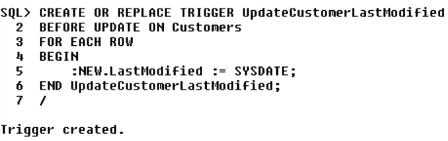

**Output:**

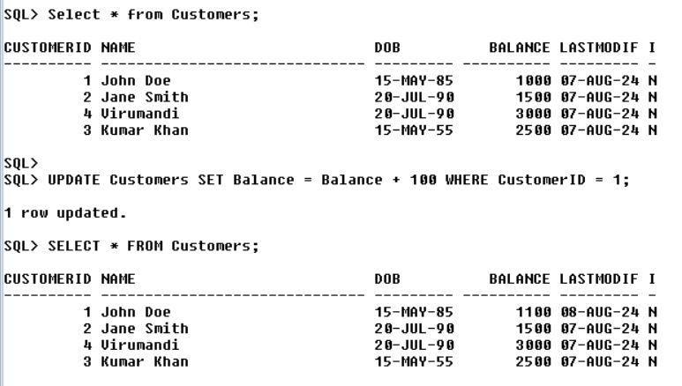

**Scenario 2: Maintain an audit log for all transactions.**

**Creating AuditLog table to store audit log for all transactions:**

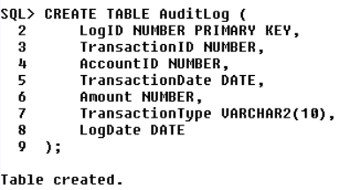

**PL/SQL Code:**

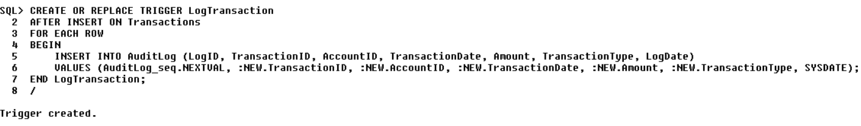

**Output:**



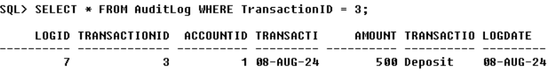

**Scenario 3:** **Enforce business rules on deposits and withdrawals.**

**PL/SQL Code:**

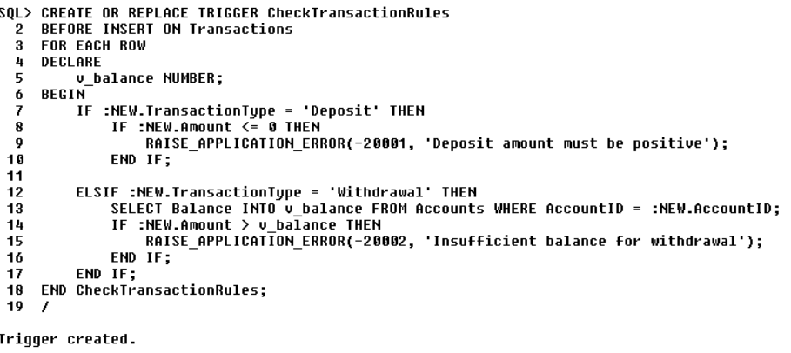

**Output:**

